DMAP Online Customer Application Instructions (ver. 2023)
Deer Management Assistance Program (DMAP) will now be using the new Go Outdoors Carolina system (GoOutdoorsNorthCarolina.com). The DMAP program includes applications for traditional Deer Management Assistance Program (DMAP), Community Deer Management Assistance Program (CDMAP) and Chronic Wasting Disease Management Assistance Program (CWDMAP). This online process will allow customers to submit applications, track approval processes, and view all reported harvests under their permit. Applications are not accessible via the GoOutdoorsNorthCarolina mobile app.
If you experience difficulties using the online system, you may call our wildlife management office for assistance at 919-707-0058 during normal business hours. Optional paper applications can be found at ncwildlife.org/deer and can be mailed to NCWRC Wildlife Management Division, 1722 Mail Service Center, Raleigh, NC 27699.
The DMAP program is designed for business entities which include: hunt clubs, farming businesses, homeowner/property associations, and corporations (see participant information requirements document for further information and requirements). Individuals cannot apply. Applications will be reviewed by a district biologist. The district biologist will determine valid season dates, tag allocations, and potential weapon restrictions on the final permit.
To apply, customers must login in the GoOutdoords.com using their Business account (“Lookup Business” tab). If you do not have an existing business account, you can create one.
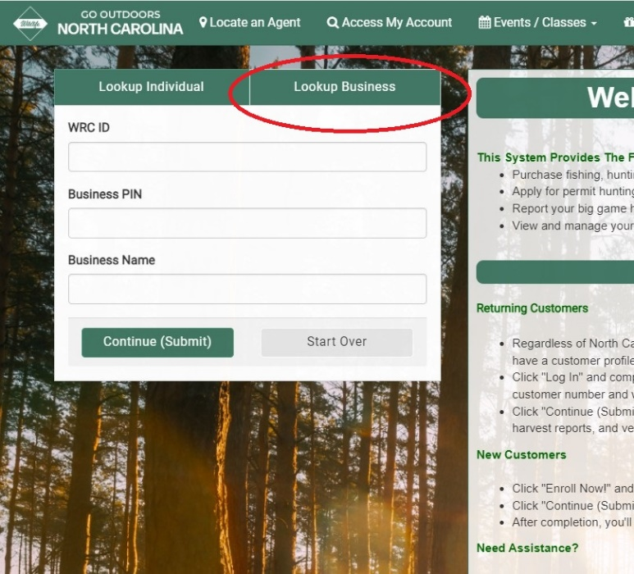

Once created, the user will be issued a WRC ID#, Business PIN, and Business Name. Please retain these login credentials for future use. These identification numbers are similar to your hunting license number and will be the same for your business entity for all future GoOutdoors transactions. Please note that your ”Business Name” must be spelled exactly, otherwise you will not be able to access your business account. These credentials will also be printed on your final approved permit.

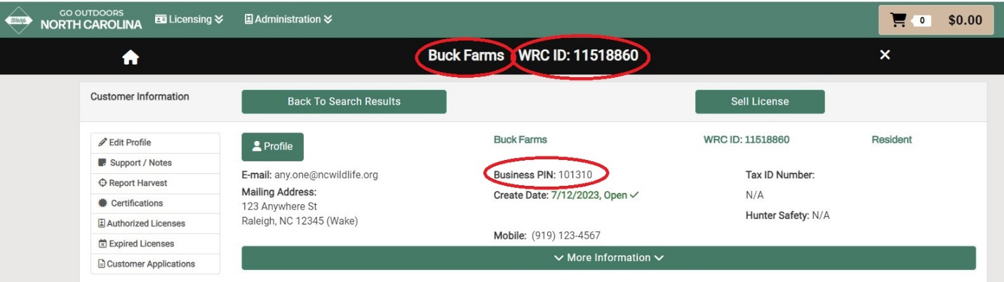

(For first time applicants, users will need to create a new business account by first searching for their business. When no results are found, select “Yes, Create Business Account.”)
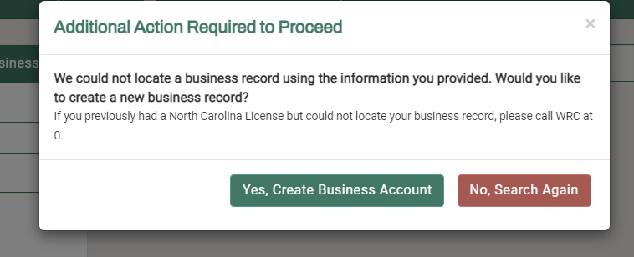

To locate the DMAP application, go to ‘Buy License’>‘Recreational Licenses’ tab>’Other Licenses and Permits’ section and select the appropriate type of DMAP application (DMAP, CDMAP, or CWDMAP). Your selection will be added to your shopping cart.
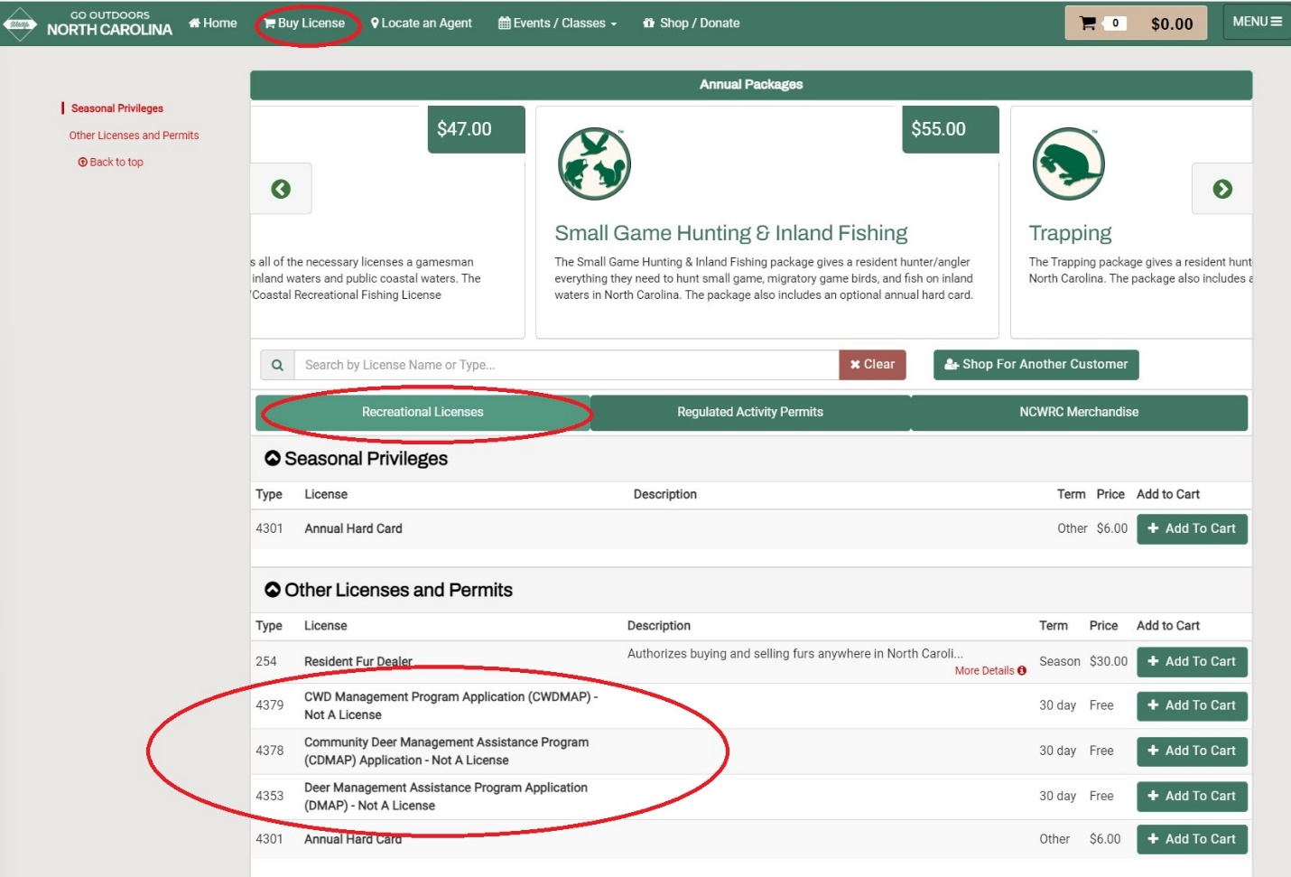
During the ‘Checkout’ process, you will be asked to complete a series of questions. When complete, press ‘Submit’ at the bottom of the page.

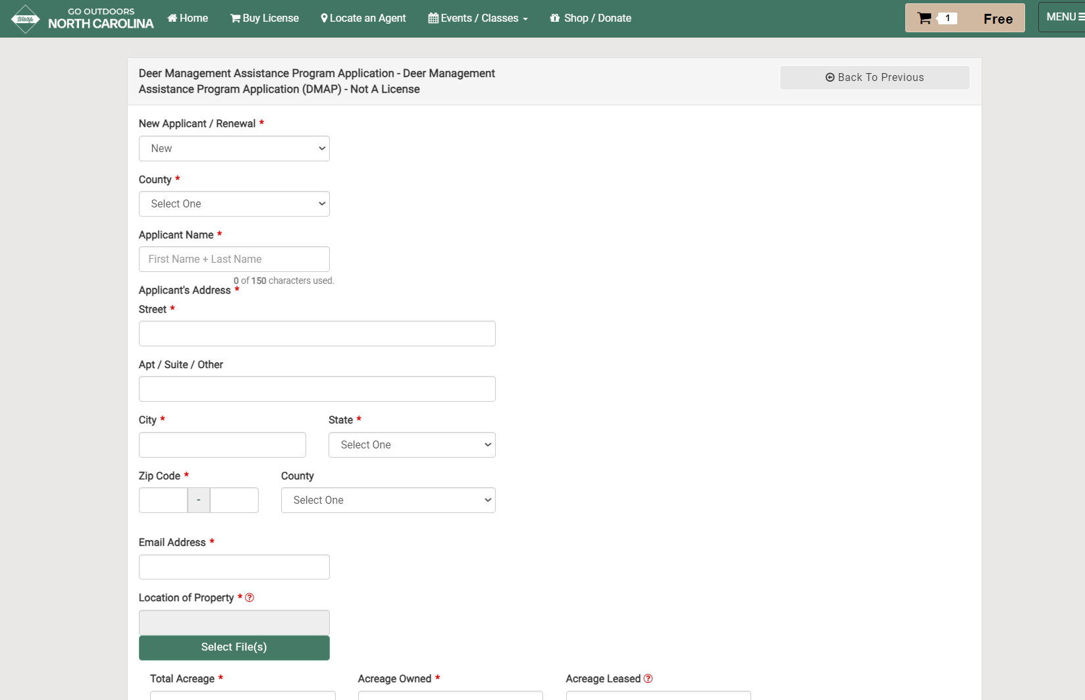
There will be no charge for submitting a DMAP application. When your transaction is complete, press “Checkout Now.” If you have a valid email address, you will receive confirmation that the application has been received and has gone into ‘Pending’ status.
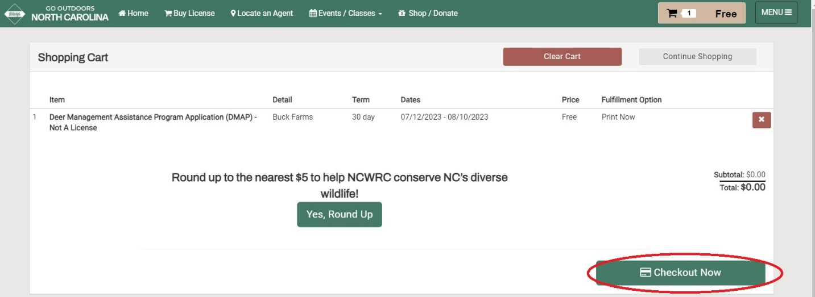
Before the coming hunting season, you will be contacted by a district biologist to review your request. Your application will go into ‘Pending’ status during this time and show under your “Current Licenses & Permits.” You may check on the status of your application by clicking on “Customer Applications” tab located on the Home page.
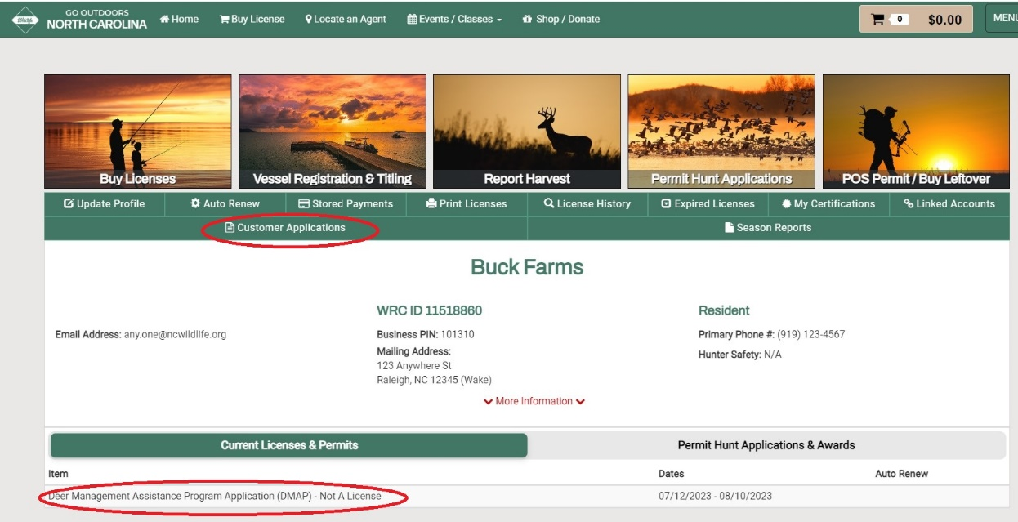

Scroll to the bottom of the “Customer Application” screen to find the “Application History” section. A yellow block will appear under ‘Application Status’ when the application is ‘Pending.’ A green block will appear when the application has been ‘Approved.’ You will receive another confirmation email when final approval is given.
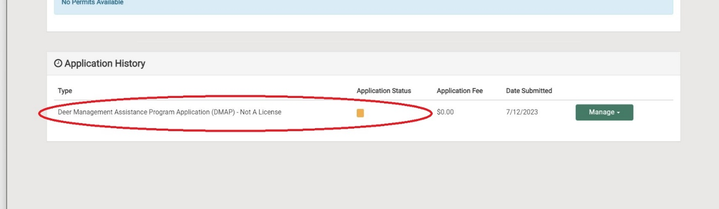

DMAP packages will be mailed after August. DMAP packages include your final authorization permit, tagging/reporting instructions, and associated deer tags. If you have any further questions, call our wildlife management office for assistance at 919-707-0050 during normal business hours.

